DATABASE
labaratory work 2
Normalization
Task 1:
Booking_receipt(booking_id, passenger_full_name, passenger_passport_number, flight_number, departure_airport_name, departure_city, arrival_airport_name, arrival_city, airline_name, seat_numbers, ticket_price)
1 Normal Form:
The table violates 1NF because the seat_numbers column can contain multiple values in one cell. It contains non-atomic values like "12A, 12B". In 1NF, every attribute must contain a single atomic value. Therefore, seat_numbers is the problem
2 Normal Form:
2NF requires the table to be in 1NF and that all non-key attributes must be fully functionally dependent on the entire primary key (no partial dependencies).
To convert the table to 1NF, a composite primary key like (booking_id, seat_number) must be used. However, attributes like flight_number, departure_airport_name, departure_city, arrival_airport_name, arrival_city, and airline_name depend only on booking_id , while passenger_full_name depends only on passenger_passport number.
3 Normal Form:
3NF requires the table to be in 2NF and that no non-key attribute depends on another non-key attribute. No transitive dependencies.
departure_city depends on departure_airport_name (booking_id $→$ departure_airport_name $→$ departure_city).
arrival_city depends on arrival_airport_name (booking_id $→$ arrival_airport_name $→$ arrival_city).
airline_name depends on flight_number (booking_id $→$ flight_number $→$ airline_name).

Task 2:
1 Normal Form:
To bring Booking_receipt to 1NF, we eliminate non atomic values from seat_numbers by expanding each seat into its own row. And we create composite primary key (booking_id, seat_number) to uniquely identify rows.
So instead of:
id | name | passport | airline | seat
1 | Ali | AB123 | FlyArystan | 12A, 12B
We do:
id | Name | passport | fligh | D_airport | city | Arr_airport | city | airline | seat | price
1 | Ali | AB123 | KZ1 | AlmatyAir | Almat | AstanaAir | Astan | FlyA | 12A | 100$
1 | Ali | AB123 | KZ1 | AlmatyAir | Almat | AstanaAir | Astan | FlyA | 12B | 100$
As we can see, id is no more uniquely represents row. So we make it composite by adding seat_number. It creates new problem of breaking 2NF.
2 Normal Form:
To eliminate partial dependencies on the composite key (booking_id, seat_number), attributes dependent only on booking_id are split into a separate booking table, and attributes dependent only on passenger_passport_number are moved to a passenger table.
- Bookings_2NF: (booking_id, flight_number, departure_airport_name, departure_city, arrival_airport_name, arrival_city, airline_name)
- Passengers_2NF: (passenger_passport_number, passenger_full_name)
- Tickets_2NF: (booking_id (FK), seat_number, passenger_passport_number (FK), ticket_price)
id | Name | passport | fligh | D_airport | city | Arr_airport | city | airline | seat | price
1 | Ali | AB123 | KZ1 | AlmatyAir | Almat | AstanaAir | Astan | FlyA | 12A | 100$
1 | Ali | AB123 | KZ1 | AlmatyAir | Almat | AstanaAir | Astan | FlyA | 12B | 100$
As you can see many records are duplicated, 2NF are against this.
So Booking:
Booking id | flight | Dep_airport | Dep_city | Arr_airport | Arr_city | airline
1 | KZ1 | AlmatyAir | Almaty | AstanaAir | Astana | FlyA

Ticket:
Booking_id | Seat_number | passport | Passenger_name | price
1 | 12A | AB123 | Ali | 100$
1 | 12B | AB123 | Ali | 100$

3 Normal Form:
To make it 3NF we remove transitive functional dependencies where non-key attributes depend on other non-key attributes inside.
Airport:
Airport_name | Airport_city
AlmatyAir | Almaty
AstanaAir | Astana
Airline:
Airline id | Airline name
1 | FlyArustan
Flight:
Flight number | Airline id | Dep_airport_name | Arr_airport_name
KZ1 | 1 | AlmatyAir | AstanaAir
Passport:
Passport | Full_name
AB123 | Ali
Booking:
Booking_id | Flight_number
1 | KZ1
Ticket:
Ticket_id | Booking_id | Passport | seat | price
1 | 1 | AB123 | 12A | 100$
2 | 2 | AB123 | 12B | 100$

Task 3:
Functional dependencies 2NF:
  - (booking_id, seat_number) -> passenger_passport_number, passenger_full_name, ticket_price
  - booking_id -> light_number, departure_airport_name, departure_city, arrival_airport_name, arrival_city, airline_name
3NF:
  - passenger_passport_number -> passenger_full_name
  - dep_airport_name -> departure_city
  - arr_airport_name -> arrival_city
  - flight_number -> airline_id, departure_airport_name, arrival_airport_name
  - airline_name -> airline_id
  - booking_id -> flight_number
Task 4:
Flights: flight_id(int), sch_departure_time(timestamp), sch_arrival_time(timestamp), departing_airport_id(int), arriving_airport_id(int), departing_gate(varchar(50)), arriving_gate(varchar(50)), airline_id(int), act_departure_time(timestamp), act_arrival_time(timestamp), created_at(timestamp), updated_at(timestamp) ;
Functional Dependencies:
  - flight_id → flight_number, departure_time, arrival_time, created_at, updated_at, act_departure_time, act_arrival_time, departing_gate
All of them are logically parametres of flight.
We need to check whether any attributes in the table depend on these attributes:
departing_airport_id, arriving_airport_id, airline_id;
Their logical attributes (city, country, names, states etc.) are not on the table, so other attributes don’t depend on them. They are just FK.

Task 5:
Code:
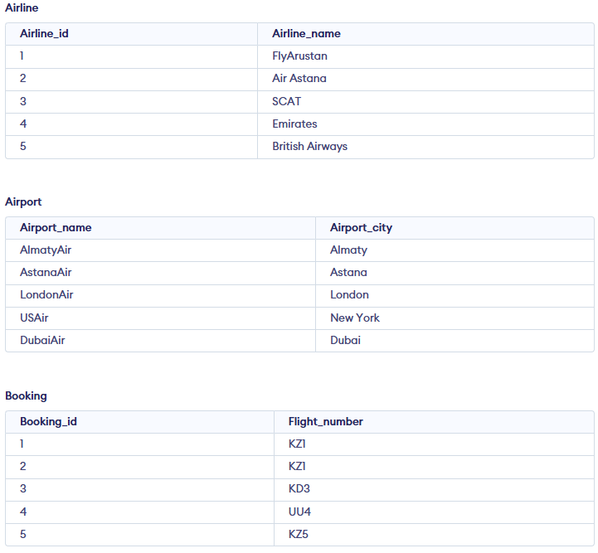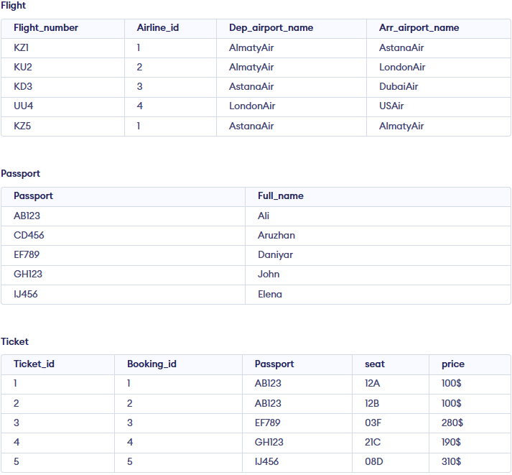

International Airport Database
This laboratory project designs and implements a relational database architecture for an International Airport operational system. The relational schema is normalized into 10 distinct entities to ensure domain data integrity and eliminate functional redundancies.

TABLES:
Name | Primary Key | Foreighn Key
Airport | airport | ---
Airline | airline id | ---
Flights | flight id | airline id, departure airport id, arrival airport id
Passengers | passenger id | ---
Booking | booking id | passenger id, flight id
Booking flight | booking flight id | Booking id, flight id
Boarding | boarding id | booking id
Baggage | baggage id | booking id
Baggage check | baggage check id | booking id, passenger id
Security check | security check id | passenger id

Connection:
Connections connect tables with foreighn and primary key attributes. To understand connections better we can divide them into 3 sections:

Flight connection:
airlines -> flights (1:N) or (1:0): One airline does many flights or might not have any flights for the moment.
airports -> flights (1:N): One airport has many departures and arrivals
Booking:
passengers -> booking (1:N): One passenger can book many tickets.
Booking -> flights (M:N): A single booking can include multiple connecting flights (segments), and many bookings are sold for a single flight.
booking -> booking_changes (1:N) or (0:N): One booking may have many changes, or may not have it.
booking -> boarding (1:1): One booking has exactly one boarding with one seat and time.
Baggage:
booking -> baggage (1:N) or (0:N): In one booking may have many baggages, or may not have it.
booking + passengers -> baggage_checks (1:N) or (0:N): Baggage checks connects passenger and its booking, and there might be more than one baggage checks, or zero.
passengers -> security_check (1:N): Passenger could went from many security checks.

Visualistion:
